DATE:19/8/2023

1. Do the following in a spreadsheet:

# Roll No Name CMSA MTMG PHSG ELTG TOTAL AVERAGE GRADE

# 149 RAMANUJ 53 45 43 12

# 17 JADAV 41 52 36 56

# 78 RAKESH 74 65 61 53

# 455 KHAYATI 12 11 15 22

# 1254 CHANDRANI 86 89 78 85

# Q.1 Find the Total Number & Average in all Subjects in Each Student.

# Q.2 Find Grade Using If Function - If Average Greater >15 then "A" Grade otherwise "B" Grade

# Q.3 How Many Student "A" and "B" Grade Use of Countif

# Q.4 Student Jadav and Chandrani Total Number and Average Use of Sumif

# Q.5 Count how many Students Use of Counta

# Q.6 How Many Student PHSG & MTMG Subject Number Grater Then > 20 and <15 Use of Countif

Formulas uses:- 1.(Total) =SUM(F9:I9) 2.(AVERAGE) =AVERAGE(F9:I9) 3.(GRADE) =IF(K9>15,”A”,”B”) 4.(TOTALSTUDENT)=COUNTA(E9:E13)

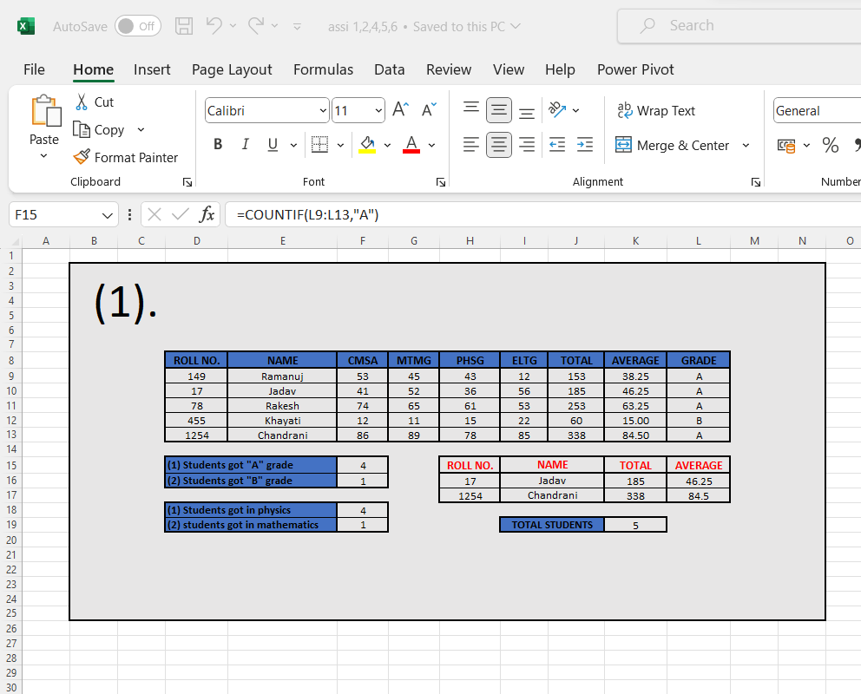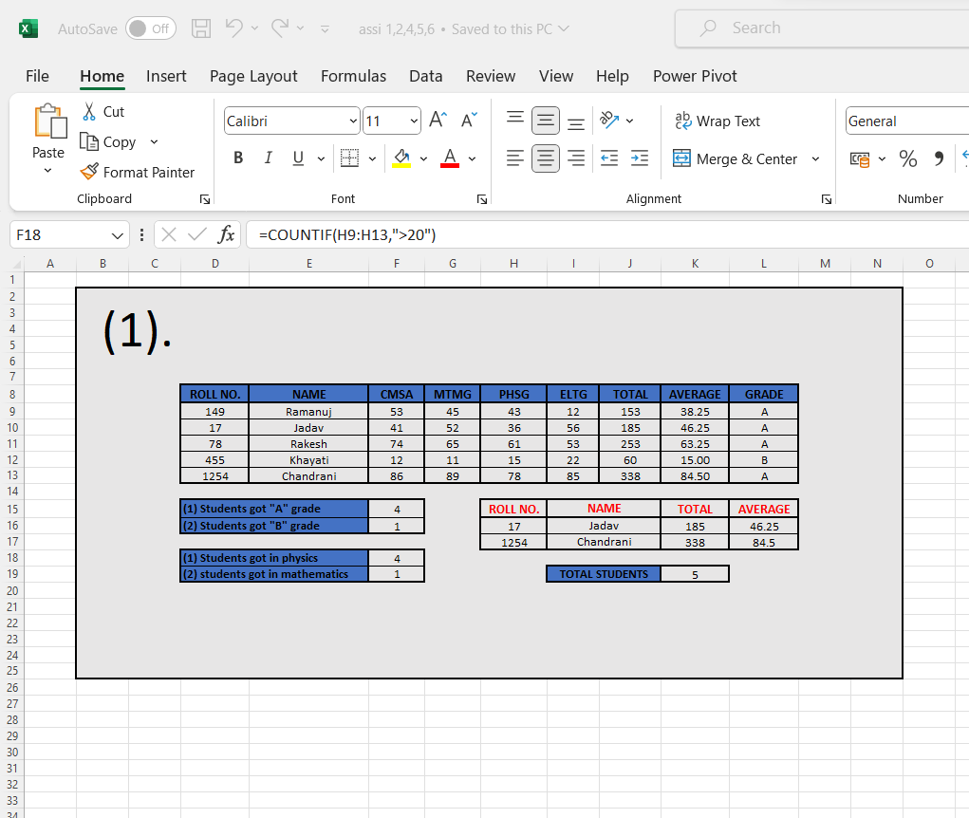

TEACHER SIGNATURE:__________________

DATE:5/9/2023

2.Do the following Spreadsheet

Emp No Name Basic DA HRA Gross Salary P.Tax Net Salary Designation

1001 Amit Shaw 21000

1002 Sunil Das 25000

1003 Anil Dutta 18500

1004 Sujit Saha 15000

1005 Moly Pal 10000

1006 Bapi Kar 12500

Calculate the formula as follows :-

a) DA as 70% of Basic,

b) HRA as 30% of ( Basic + DA),

c) Gross Salary as sum of Basic + DA + HRA

d) P.Tax as 5% of Gross Salary

e) Net Salary as difference between Gross Salary and P.Tax

f) Calculate Designation as follows :

If Net Salary>=40000 then Designation =’Manager’,

Else if Net Salary>=35000 then Designation = ‘Officer,

Else if Net Salary>=30000 then Designation=’Clerk’,

Else Designation=’Peon’

Formulas uses:-

1. (DA) =F7*70/100
2. (HRA) =(F7+G7)*30/100
3. (GROSS SALARY) =SUM(F7+G7+H7)
4. (P.TAX) =I7*5/100

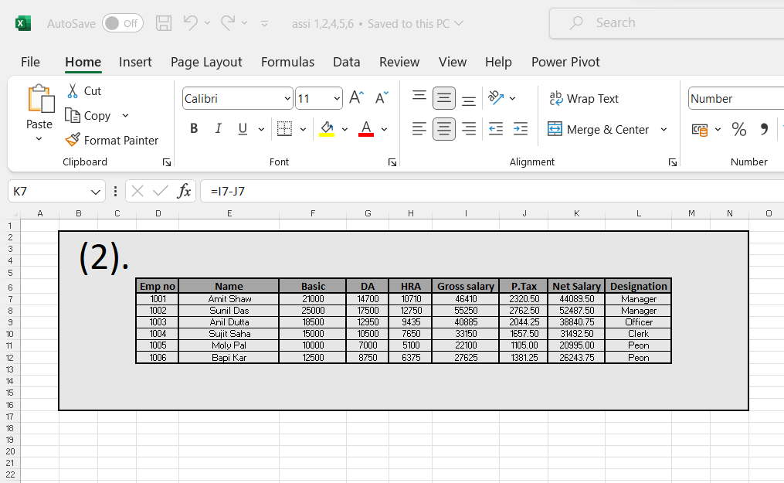

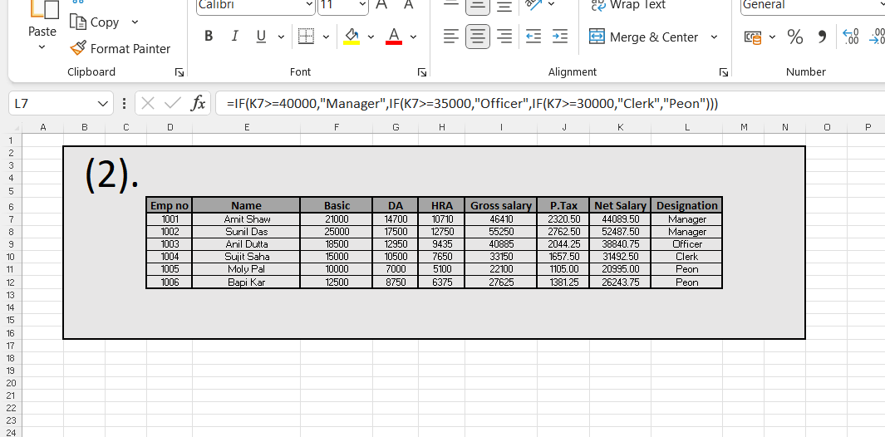

TEACHER SIGNATURE:______________

DATE:26/9/2023

3.a)Create a new workbook as shown below and save the file with the name “Payroll”.

b) Enter the labels and values in the exact cells locations as desired.

c) Use AutoFill to put the Employee Numbers into cells A6:A8.

d) Set the columns width and rows height appropriately.

e) Set labels alignment appropriately.

f) Use warp text and merge cells as desired.

g) Apply borders, gridlines and shading to the table as desired.

i) Format cells E4:G8 to include Rs. sign with two decimal places.

j) Calculate the Gross Pay for employee; enter a formula in cell E4 to multiply Hourly Rate by Hours Worked.11.

Calculate the Social Security Tax (S Tax), which is 6% of the Gross Pay; enter a formula in cell F4 to multiply Gross Pay by 6%.

k) Calculate the Net Pay; enter a formula in cell G4 to subtract Social Security Tax from Gross Pay.

l) Set the work sheet vertically and horizontally on the page.

m) Save your work.

EMP NO. EMP NAME HOURLY RATE HOURS WORKED GROSS PAY S. TAX NET PAY

E001

Formulas uses:-

1. (Gross pay) =(C2*D2)
2. (S.TAX) =(E2*6%)

3.(NET PAY) =(E2-F2)

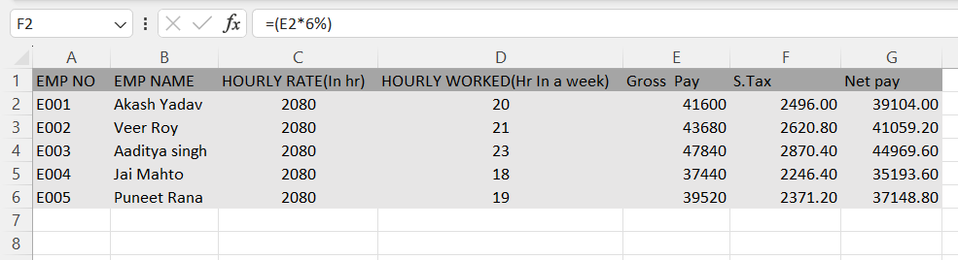

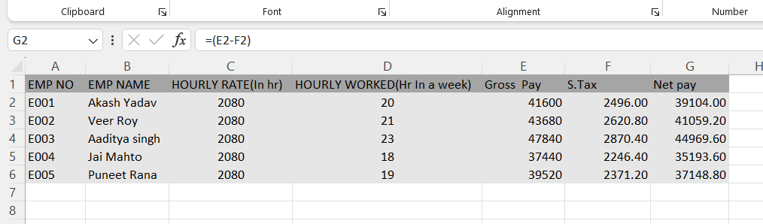

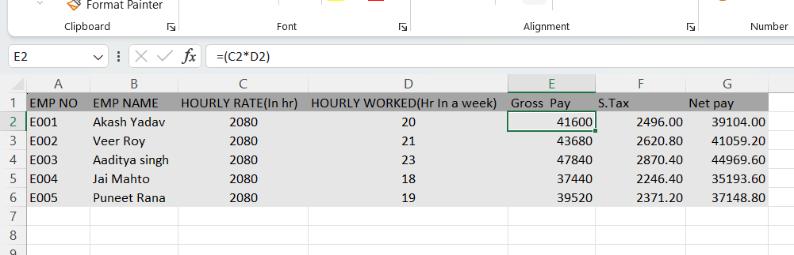

TEACHER SIGNATURE:____________

DATE:7/10/2023

4.Create a datasheet that shows item wise Total Sale Amount, Grand Total of Sale Amount of different electronic goods sold at a particular Shopping Mall. ( Use Subtotal feature of SpreadSheet).

Formula uses:-

1.(S.Total of product A) =SUBTOTAL(9,H7:H10)

2.(S.Total of product B) =SUBTOTAL(9,H13:H16)

3.(S.Total of product C) =SUBTOTAL(9,H19:H22)

4.(GRAND TOTAL OF ALL PRODUCT) =SUM(E11,E17,E23,E29)

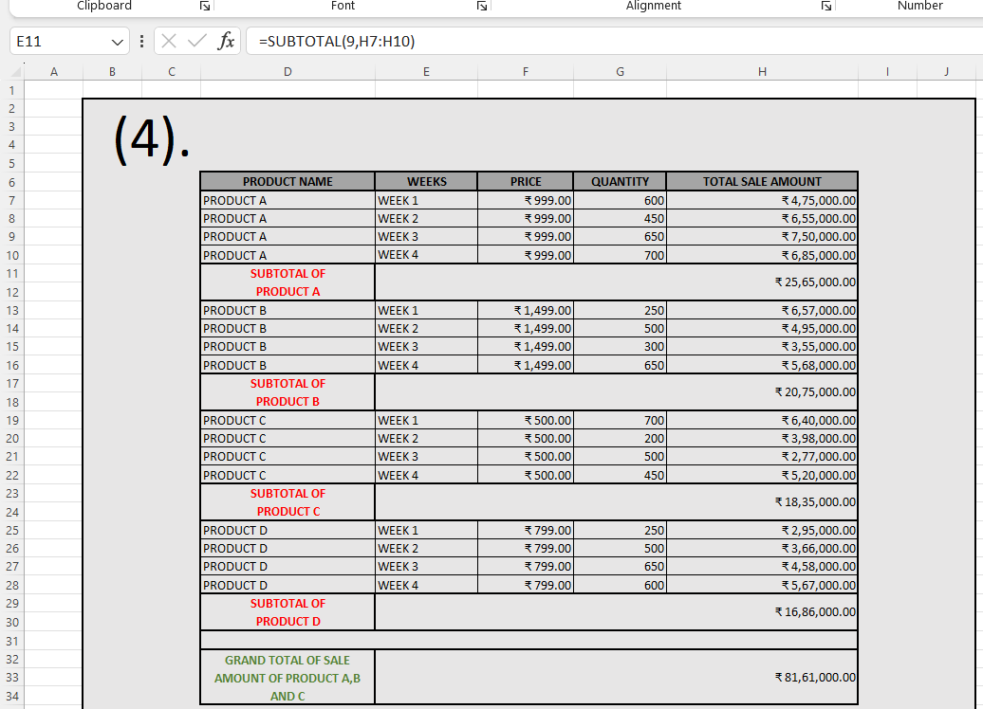

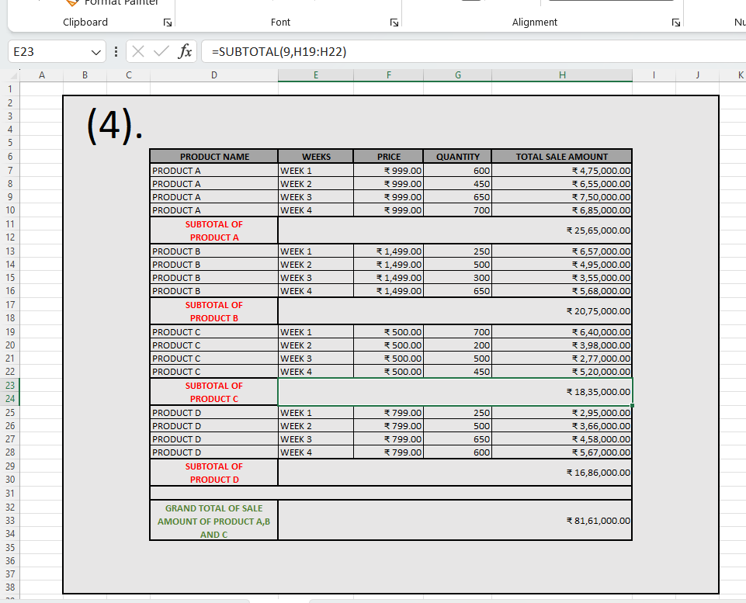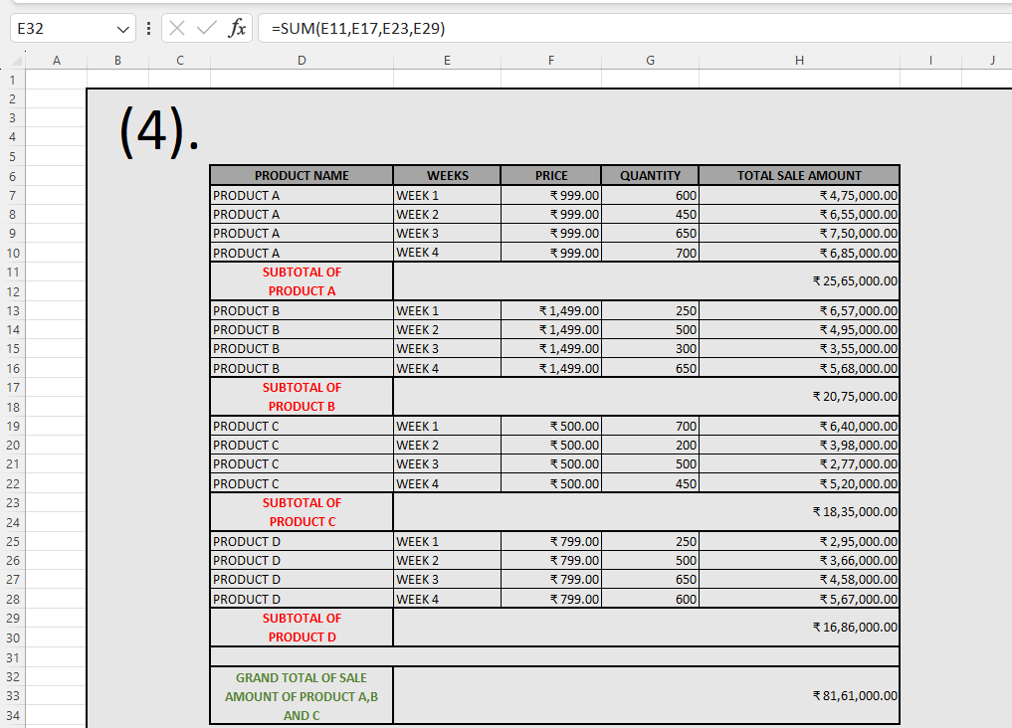

TEACHER SIGNATURE:__________________

DATE:10/10/2023

5. Calculate mean, median and mode of the following data 55,32,25, 46, 45,43, 46, 54, 75 using spreadsheet functions.

Formula Uses:-

1.(MEAN) =AVERAGE(F6:N6)

2.(MEDIAN) =MEDIAN(F6:N6)

3.(MODE) =MODE(F6:N6)

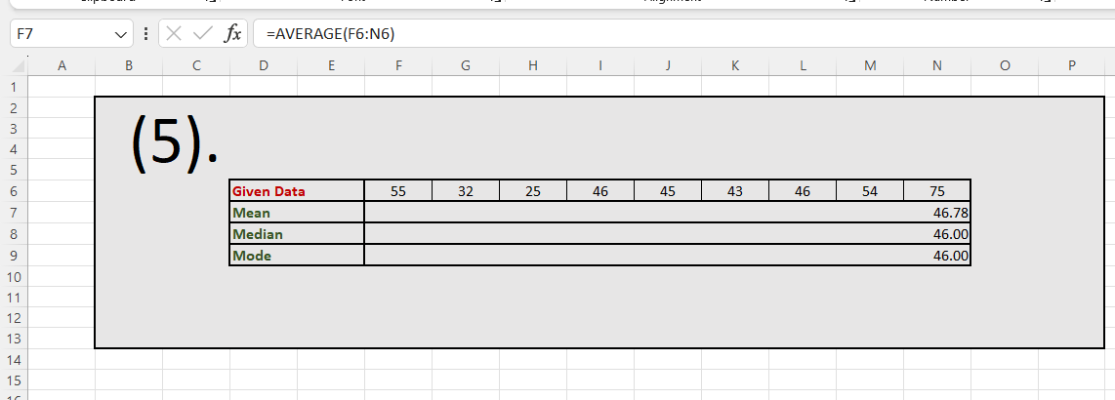

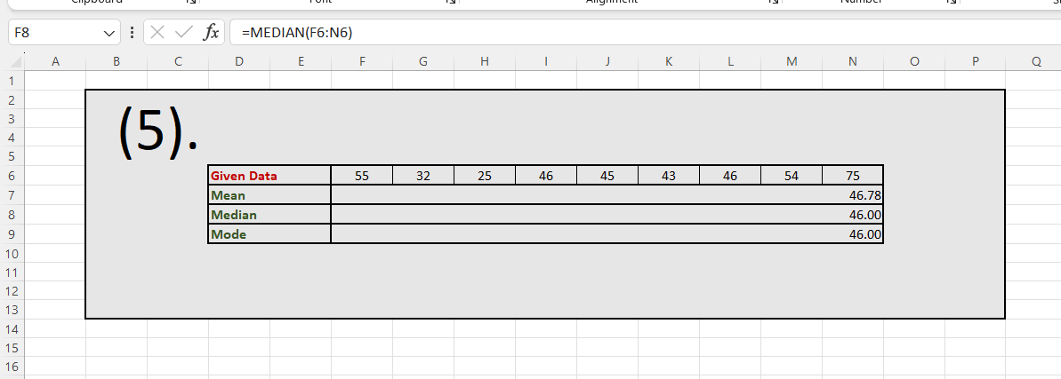

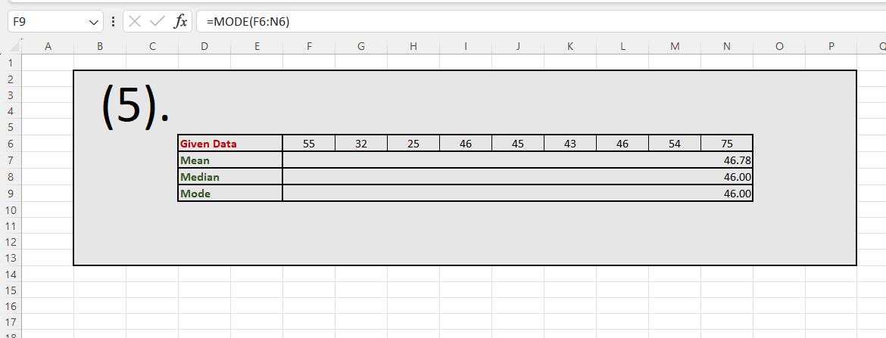

TEACHER SIGNATURE:__________________

DATE:12/10/2023

6.Calculate correlation coefficient of the given sets of data using spreadsheet function.

x 50 51 52 53 54

y 3.1 3.2 3.3 3.4 3.5

Formula Uses:-

1.(CORRELATION COEFFICIENT) =CORREL(D5:H6,D7:H8)

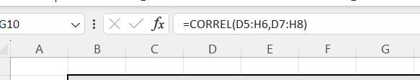

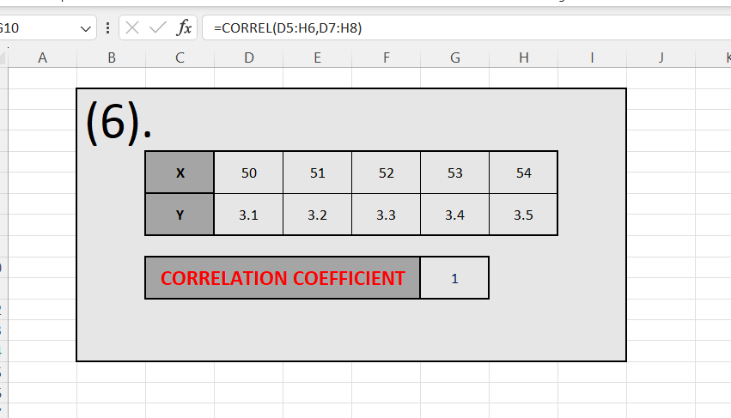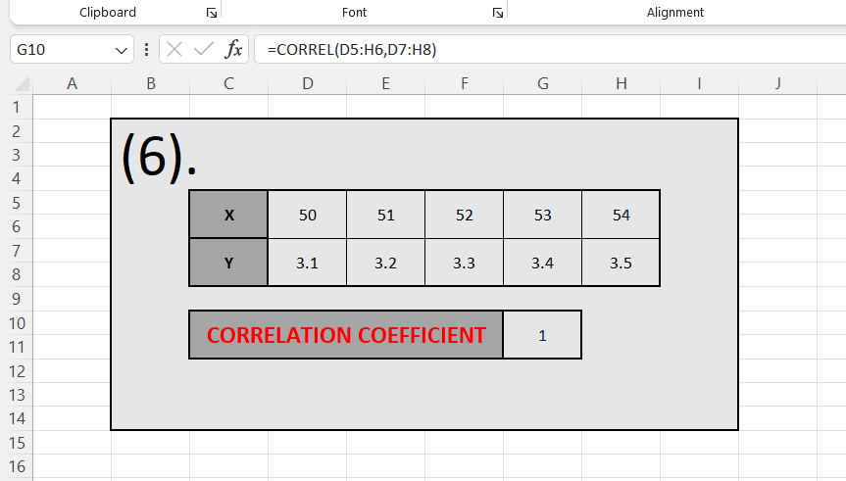

TEACHER SIGNATURE:______________________

DATE:21/10/2023

7.Create a personal budget spreadsheet that tracks income, expenses, and savings over a specified period. Use formulas and functions to calculate totals, percentages, and remaining balances.

..Formula Uses:-

1. (Total Income) =SUM(H6:H17)
2. (Total Expanses) =SUM(I6:I17)
3. (Percentage Income) =AVERAGE(H6:H17)
4. (Percentage Saving) =AVERAGE(J6:J17)
5. (Grand Remaining Balance) =SUM(L6:L17)

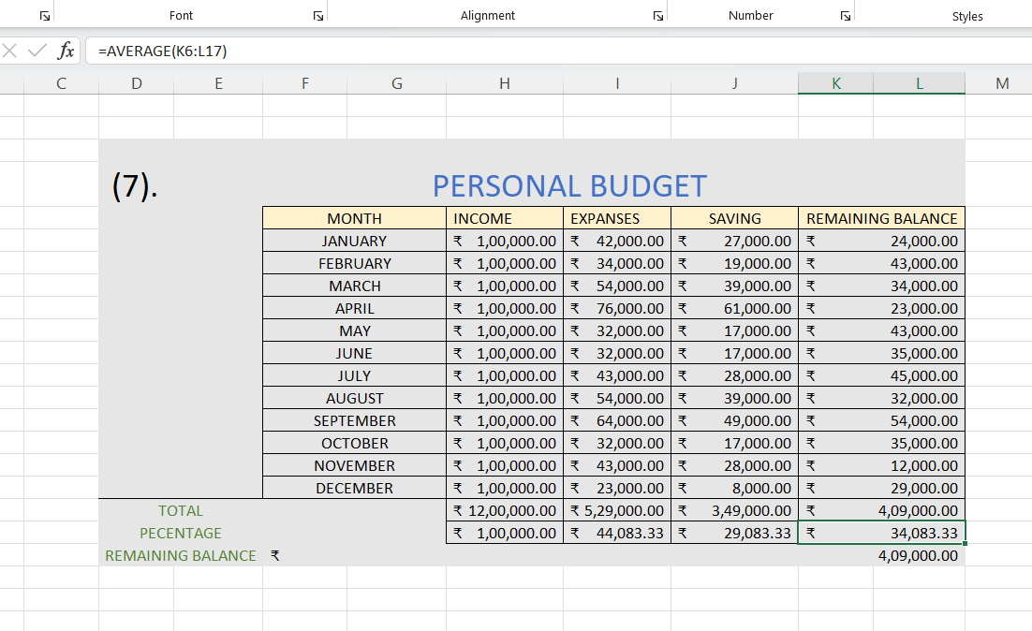

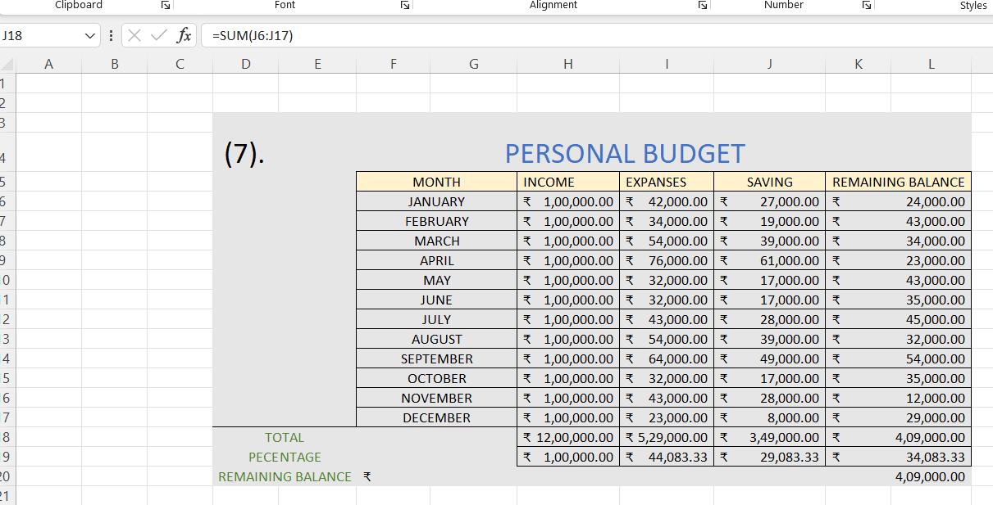

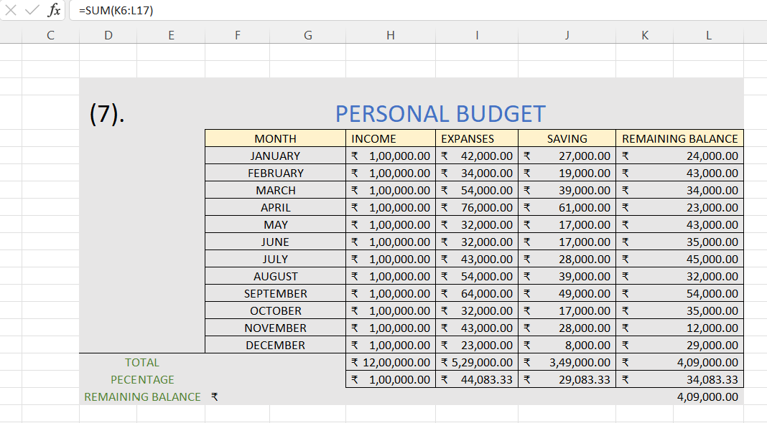

TEACHER SIGNATURE:____________________

DATE:29/11/2023

8.Design a grade book spreadsheet that calculates students' final grades based on assignments, exams, and participation. Incorporate weighted grading systems, formulas for calculating averages, and conditional formatting to indicate performance levels. Generate reports to track individual student progress.

Formulas Uses:-

1. (WEIGHTED GRADING)

=(B2*30%)+(C2*30%)+(D2*300%)+(E2*300%)+(F2*100%)

1. (FINAL GRADE) =IF(G2>=1600,"A","B")

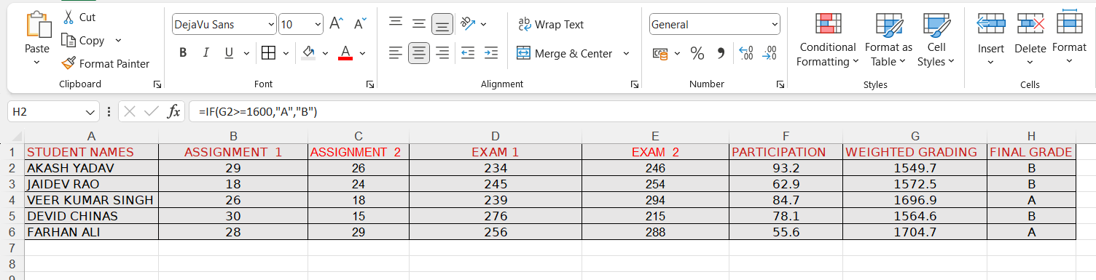

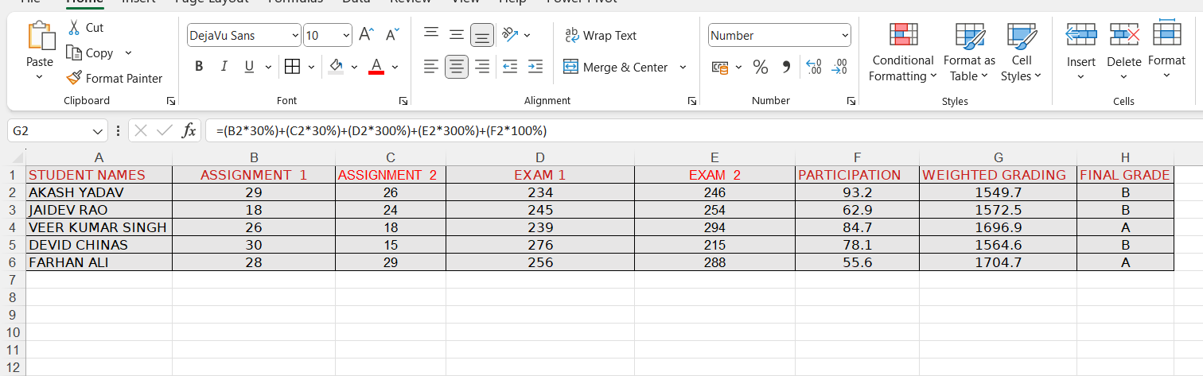

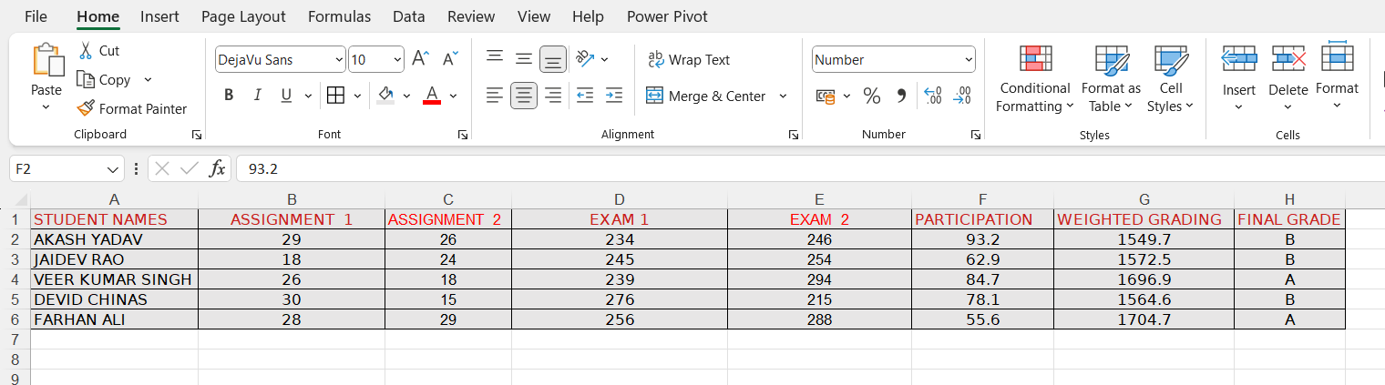

TEACHER SIGNATURE:____________________

DATE:14/12/2023

9. A dataset containing sales data for a company . Create a spreadsheet that calculates monthly sales totals, identifies top-selling products, and visualizes sales trends using bar graphs. Use conditional formatting to highlight exceptional sales performances.

Formulas Uses:-

1. (MONTHLY SALES TOTALS) =(C2*12)
2. {GRND TOTAL AMOUNT FOR SELLING PRODUCTS (RS)} =SUM(D2:D11)

3. USE BAR GRAPH

4. USE CONDITIONAL FORMATTING IN MONTHLY SALES TOTALS

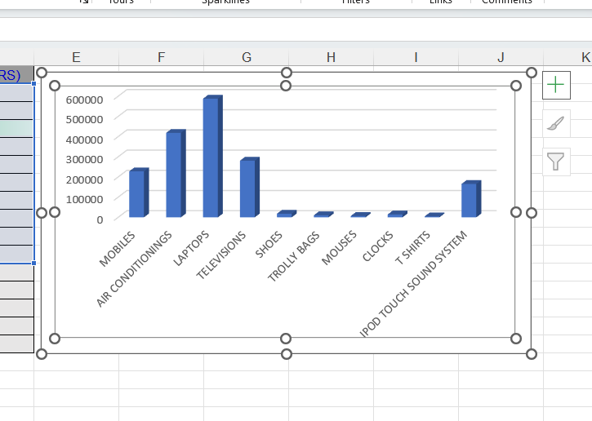

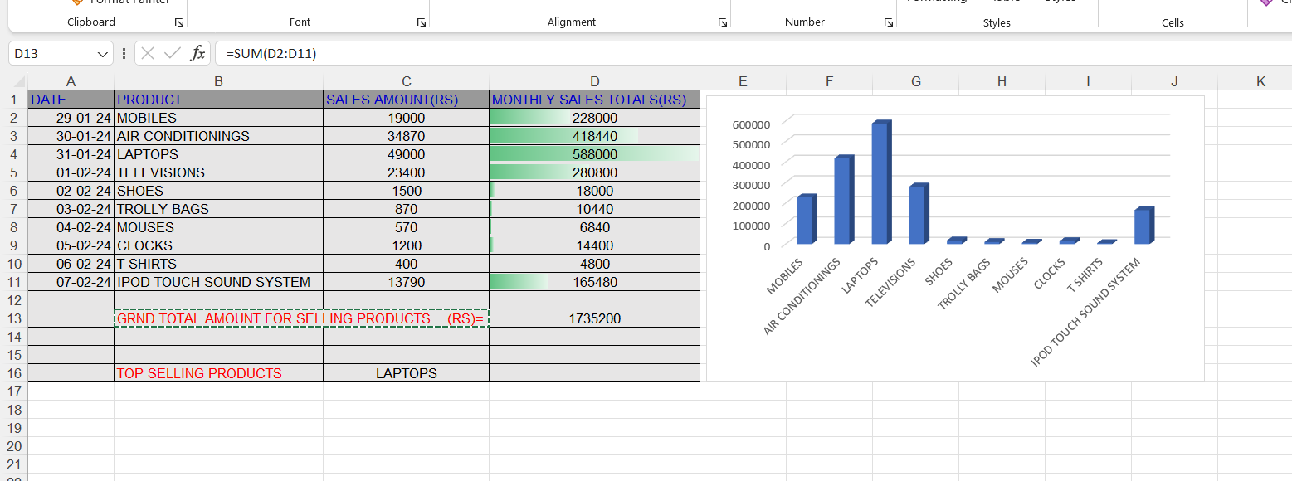

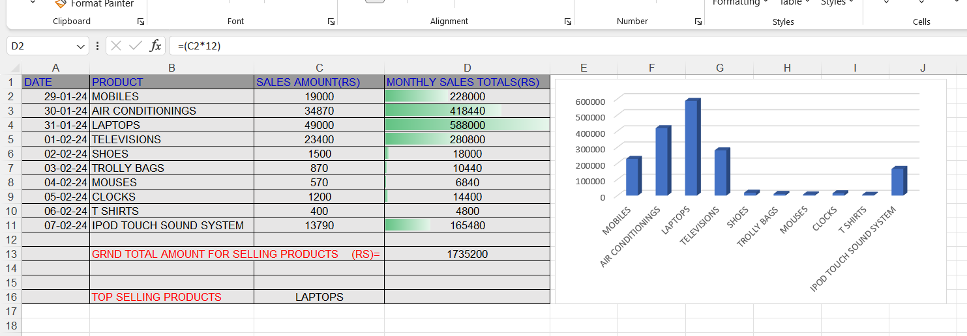

TEACHER SIGNATURE:_____________________

DATE:20/12/2023

10.Create a spreadsheet that tracks inventory for a company that includes columns for item names, quantities, prices, and total values. Use formulas to automatically update inventory totals, generate alerts for low stock, and create visualizations to represent inventory levels over time.

Formulas uses:-

1. (TOTAL VALUES) =(D2*E2)
2. (OVERALL QUANTITIES) =SUM(D2:D6)
3. (TOTAL PRIZE VALUES) =SUM(E2:E6)

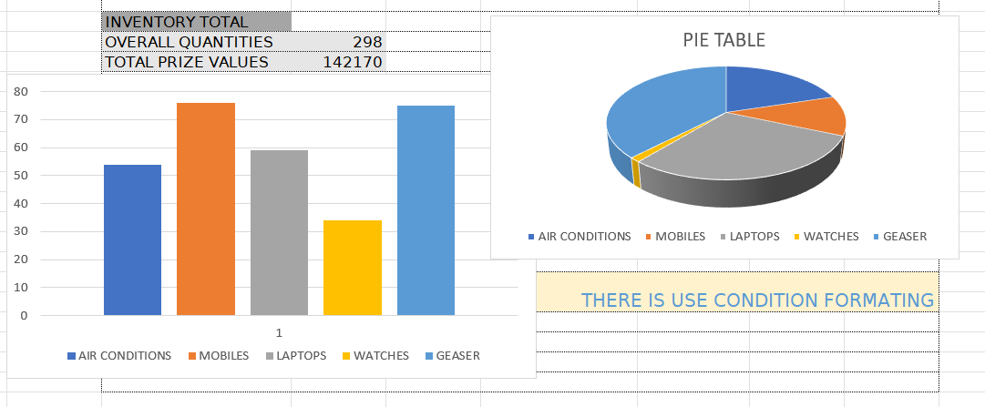

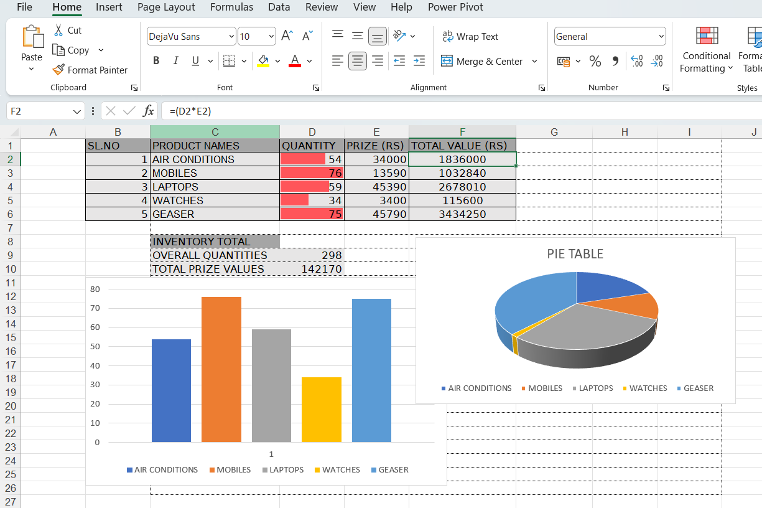

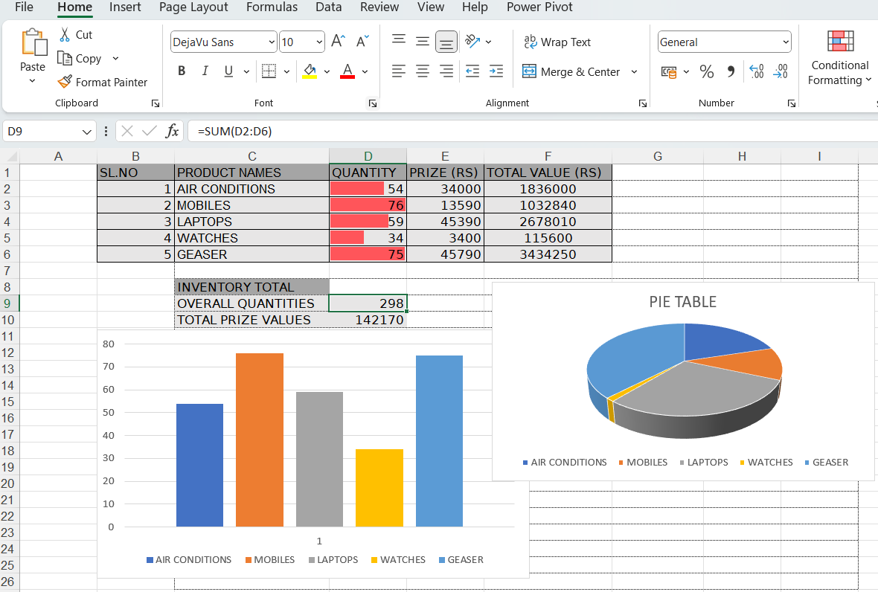

TEACHER SIGNATURE:_________________

DATE:3/1/2024

11.Loan parameters, such as principal amount, interest rate, and loan term to be provided. Create a spreadsheet that calculates monthly loan payments, remaining balances, and interest paid over time using appropriate formulas. Create a chart to visualize the loan's repayment schedule.

Formula Uses:-

1.(PRINCIPAL) =PPMT($H$1/12,A4,$E$1,$B$1)

2.(NTEREST) =IPMT($H$1/12,A4,$E$1,$B$1)

3.(EMI) =PMT($H$1/12,$E$1,$B$1)

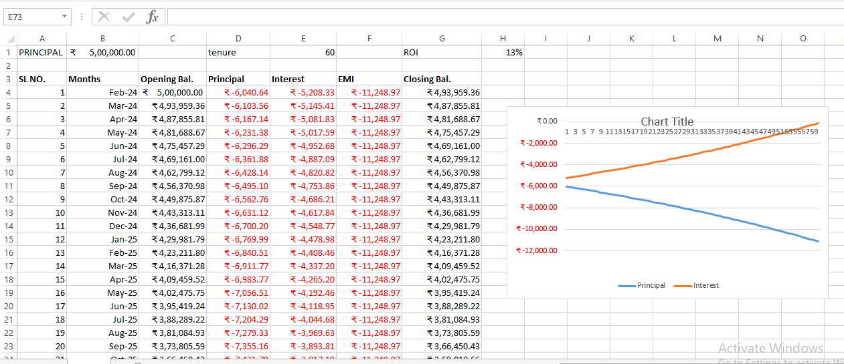

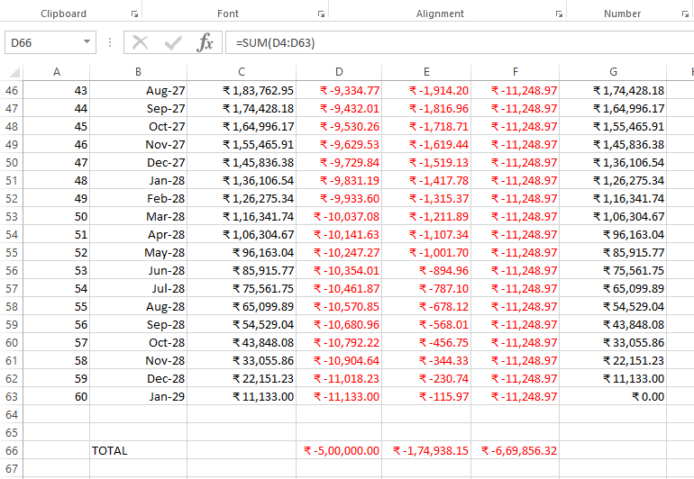

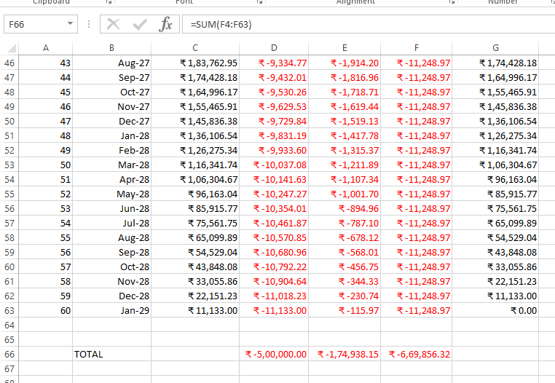 TEACHER SIGNATURE:_______________________

DATE:9/1/2024

12.Design a spreadsheet which will allow various data analysis tasks using spreadsheets. Calculation of summary statistics, sorting and filtering data, creating pivot tables for deeper insights, and generation of charts to visualize patterns or trends within the data. **Formulas uses:-**

1. ONLY THERE IS USE PIVOT TABLE
2. DATA ANALYSIS

3.USE CHART TO VISUALIZE TRENDS

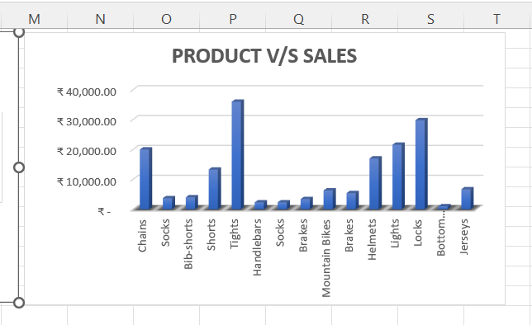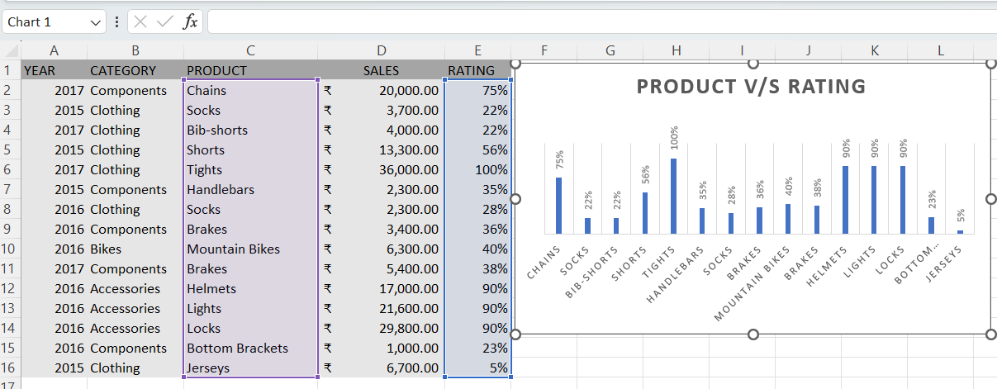

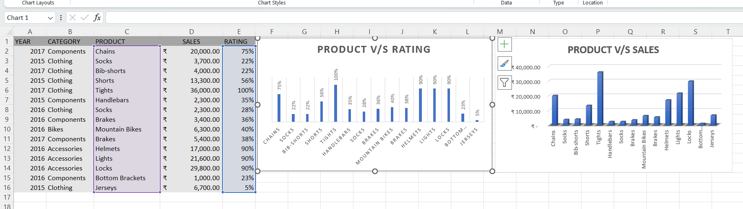

TEACHER SIGNATURE:_________________________

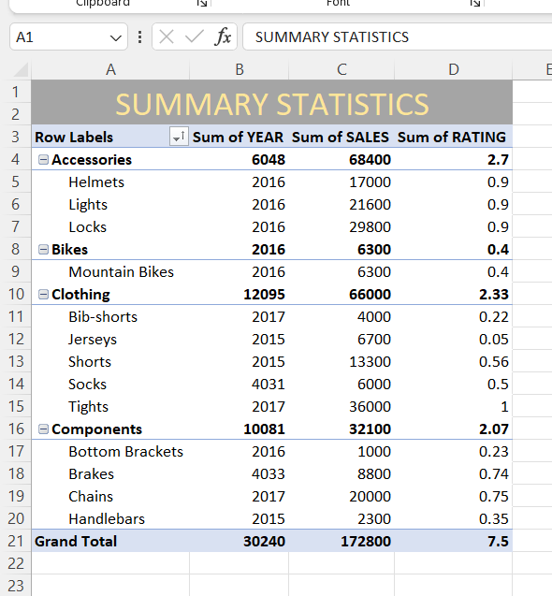

DATE:11/1/2024

13.Design a spreadsheet which will show population growth in a country over the years and create line charts to visualize trends over time. Students should choose appropriate chart types, label axes, and add titles and legends to make the visualization clear and informative.

FORMULAS USES:1. (PRESENT POPULATION) =C2-B2+D2

2.(RANKING) =RANK.EQ(E2,$E$2:$E$15)

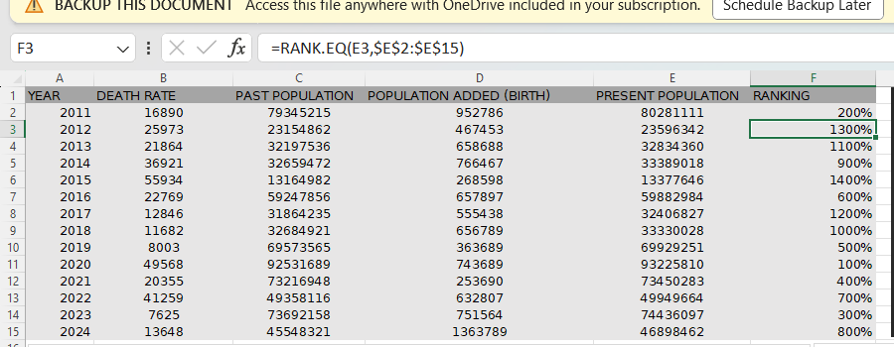

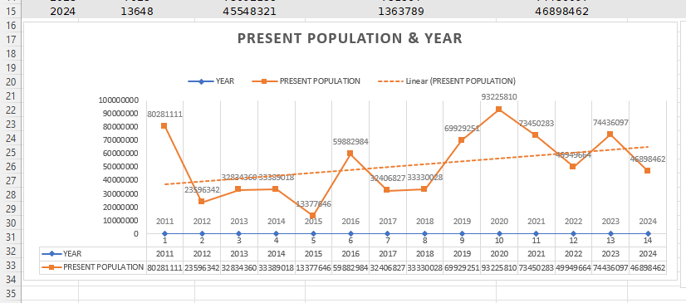

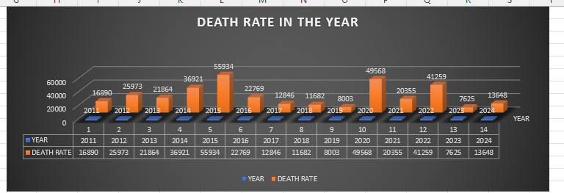

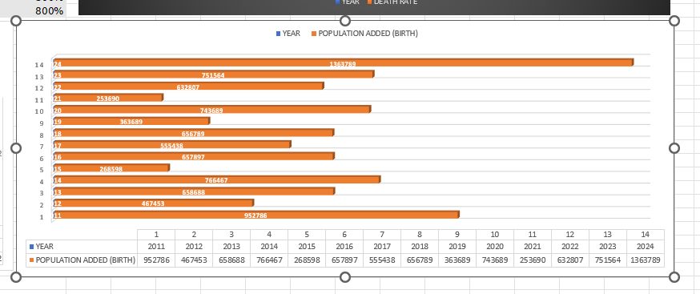

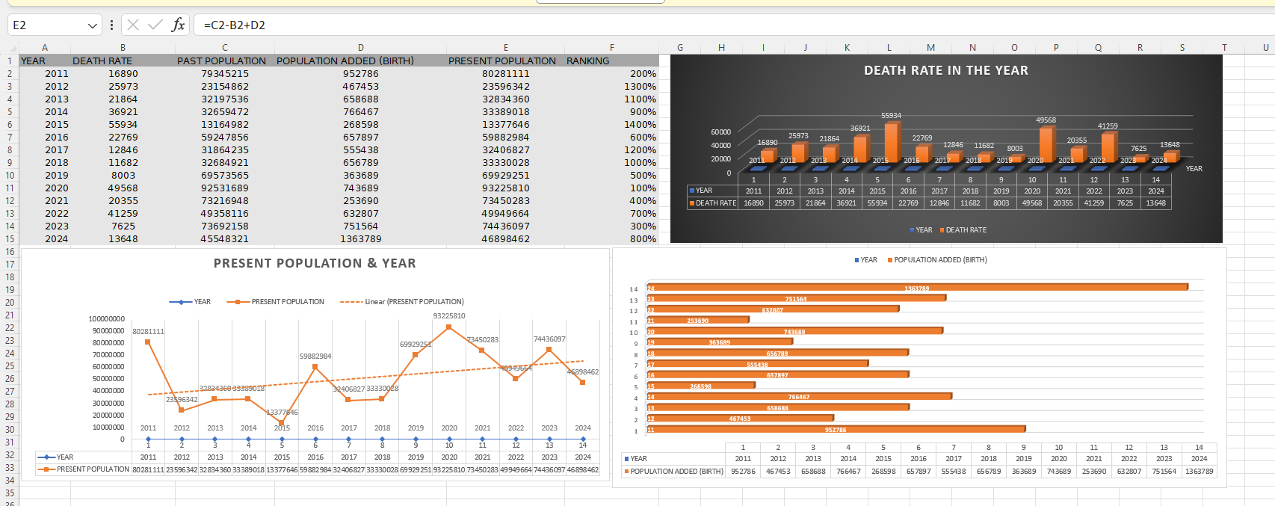 TEACHER SIGNATURE: ______________________

DATE:18/1/2024

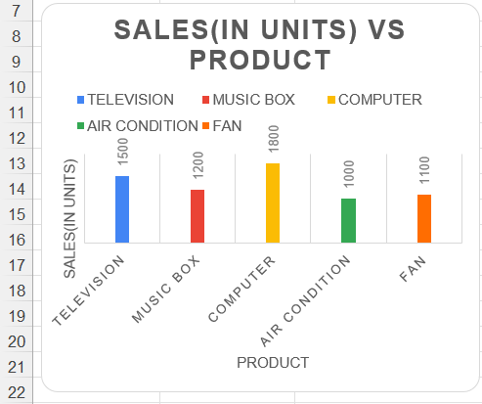14.Design a dataset containing information about different products or variables , sales data, customer satisfaction ratings) ; create column charts to compare the performance or rankings of the items. Use color, data labels, and chart elements to enhance the visual comparison.

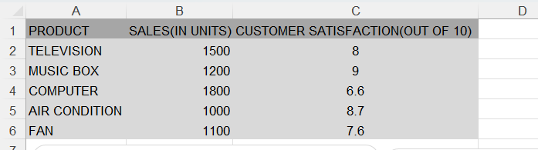

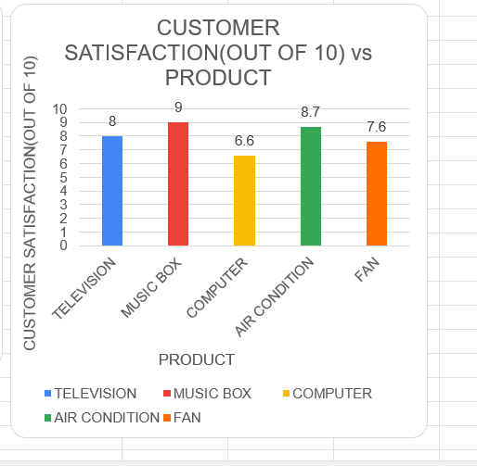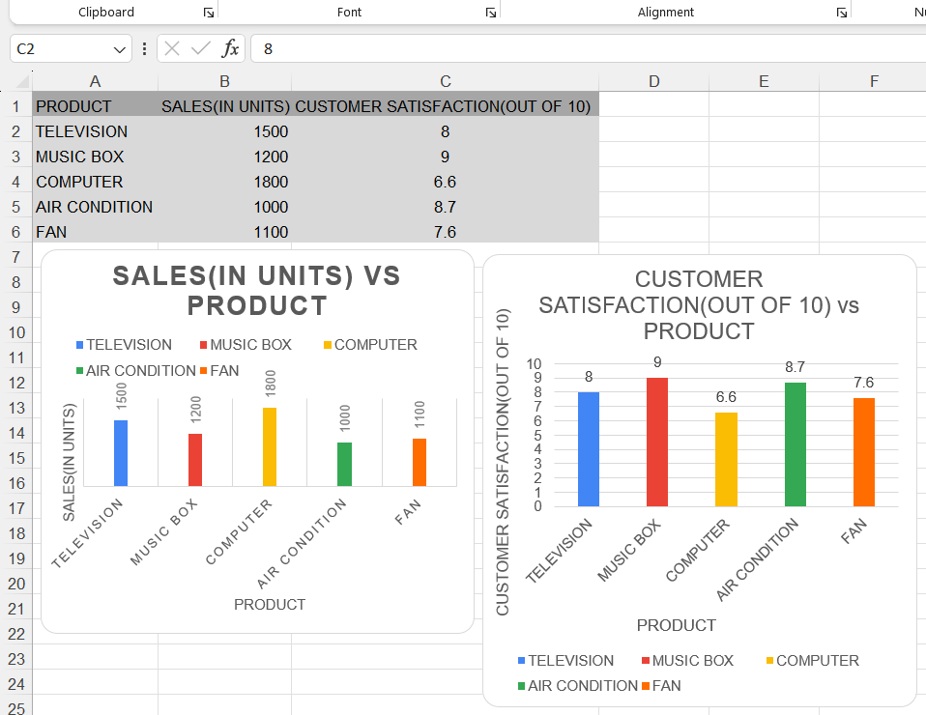 TEACHER SIGNATURE:________________

DATE:22/1/2024

15.A dataset containing time-series data for multiple variables ( monthly sales data for different products) and the following task to be performed; to create a combo chart with lines and columns to compare the trends of the variables and identify any relationships or patterns.

THERE IS NOT USE ANY FORMULAS …ONLY USE LINE CHART AND COLUMN CHART

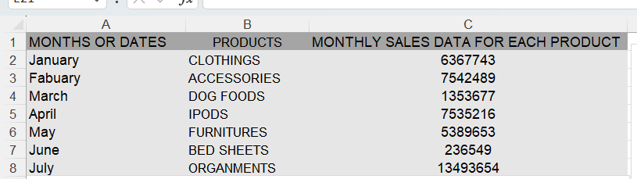

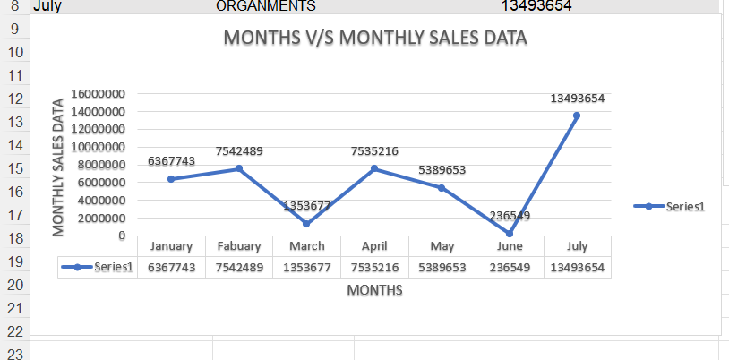

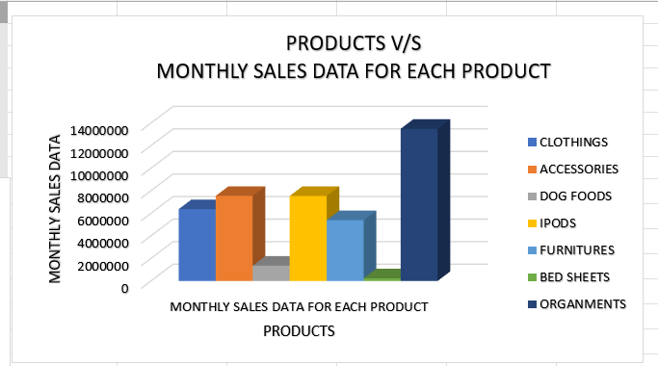

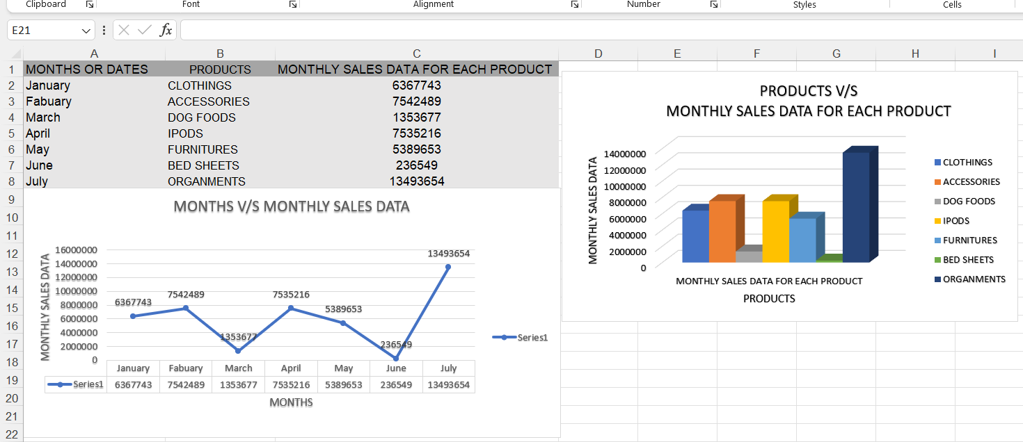

TEACHER SIGNATURE:_________________

Date:-25/1/2024

16.Design an interactive dashboard using a spreadsheet. Combine various chart types, slicers, and drop-down menus to allow users to explore and interact with the data dynamically. Create an intuitive and user-friendly interface.

**FORMULA uses:** 1.(Total purchasing amount) =E2*F2

2.(TOTAL SALES)=E2*H2

3.(TOTAL PROFITS)=I2-G2

4**.**Using slicer, drop down, interactive dashboard

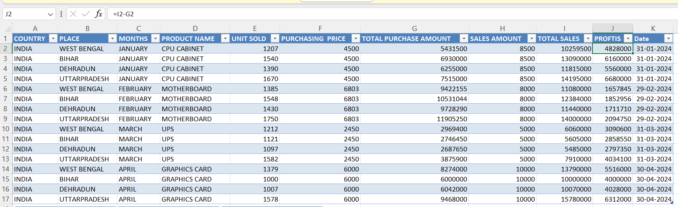

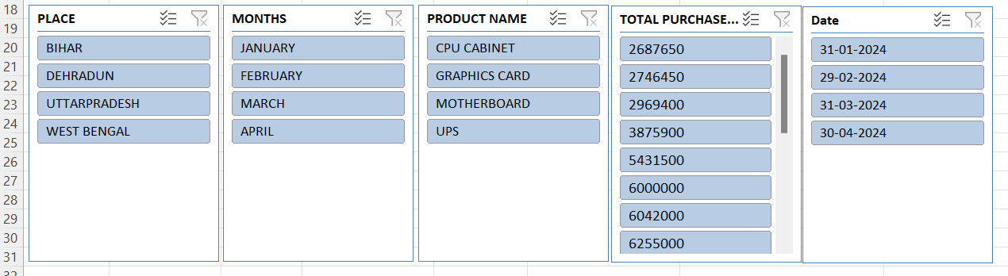

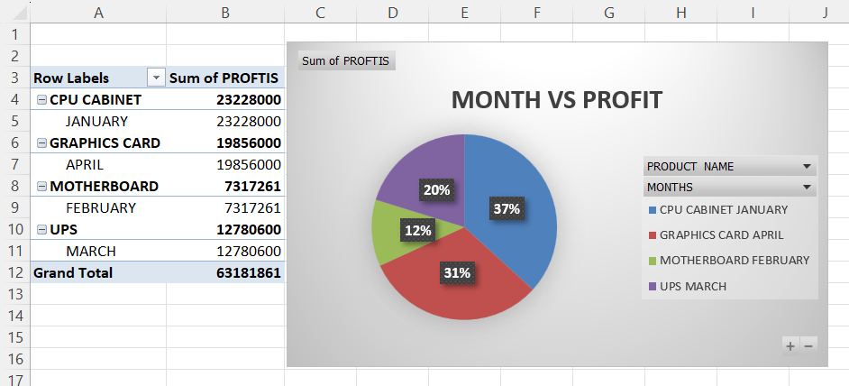

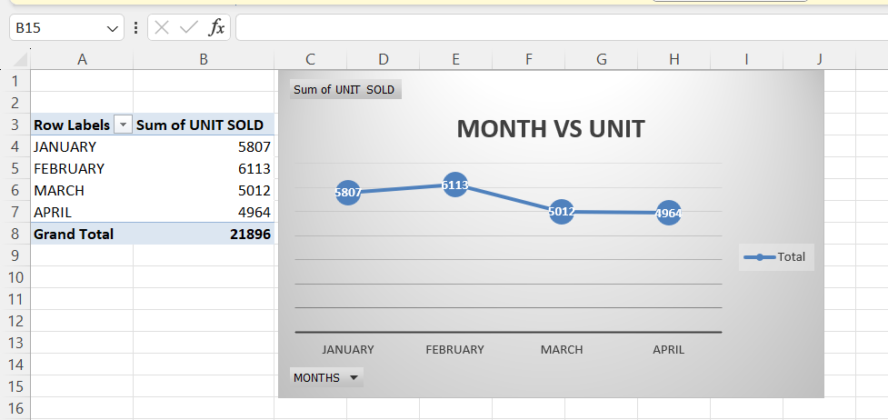

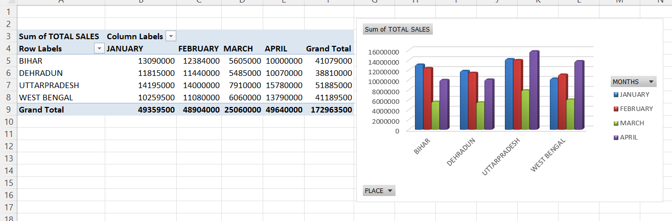

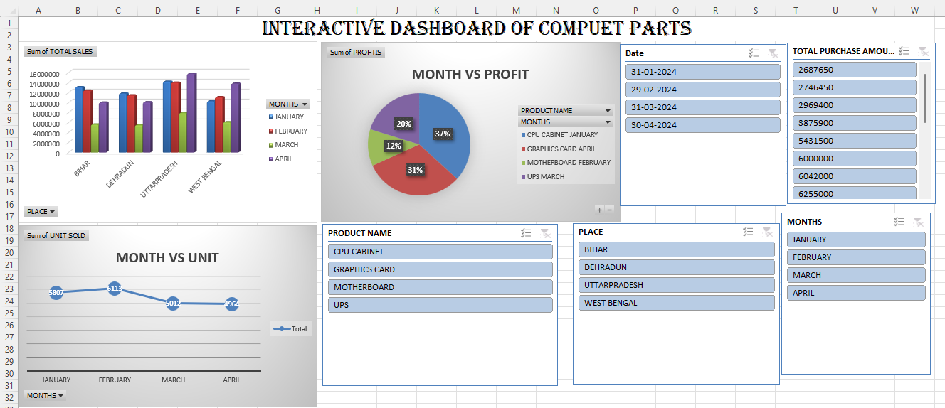

Teacher signature:__________________________

Date:30/1/2024

17.To create a unique visualization using advanced spreadsheet features and tools. For example, an experiment with sparklines, radar charts, or treemaps to represent specific types of data or explore innovative ways to visualize information

Formulas Uses:-1.(Top speed of s) =STANDARDIZE(B3,AVERAGE($B$3:$G$3), STDEV.S($B$3:$G$3))

2.(Nitro boost of s) =STANDARDIZE(B4,AVERAGE($B$4:$G$4),STDEV.S($B$4:$G$4))

3.Perfect Run of s) =STANDARDIZE(B5,AVERAGE($B$5:$G$5),STDEV.S($B$5:$G$5))

4.(Upgrade level of s) =STANDARDIZE(B6,AVERAGE($B$6:$G$6),STDEV.S($B$6:$G$6))

5. using Treemap, rader chart

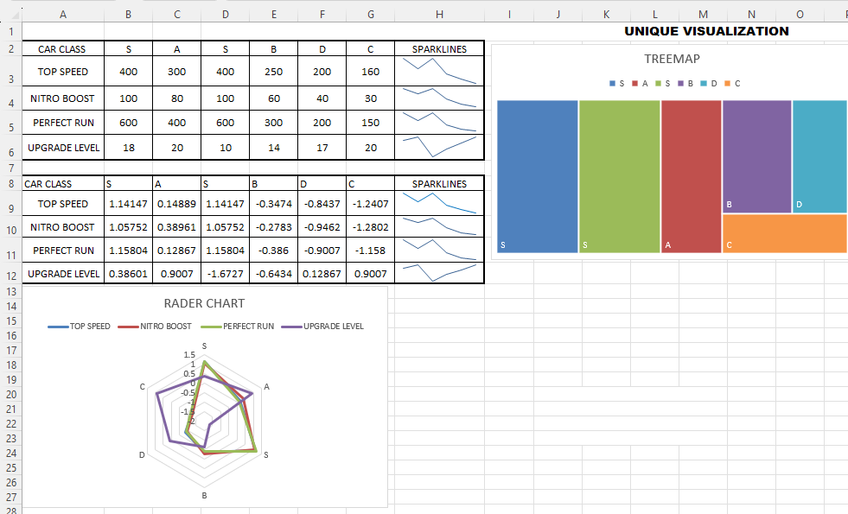

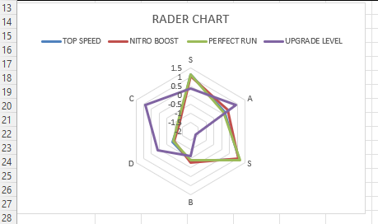

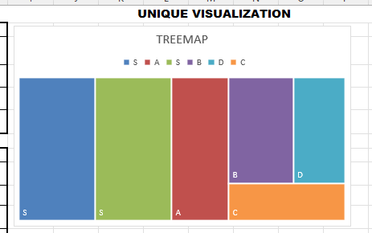

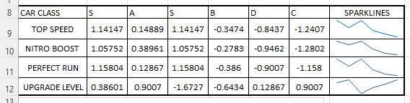 Teacher Signature:___________________